Day 2 intermediate level:

11.Given an array of integers, find the smallest missing positive integer.

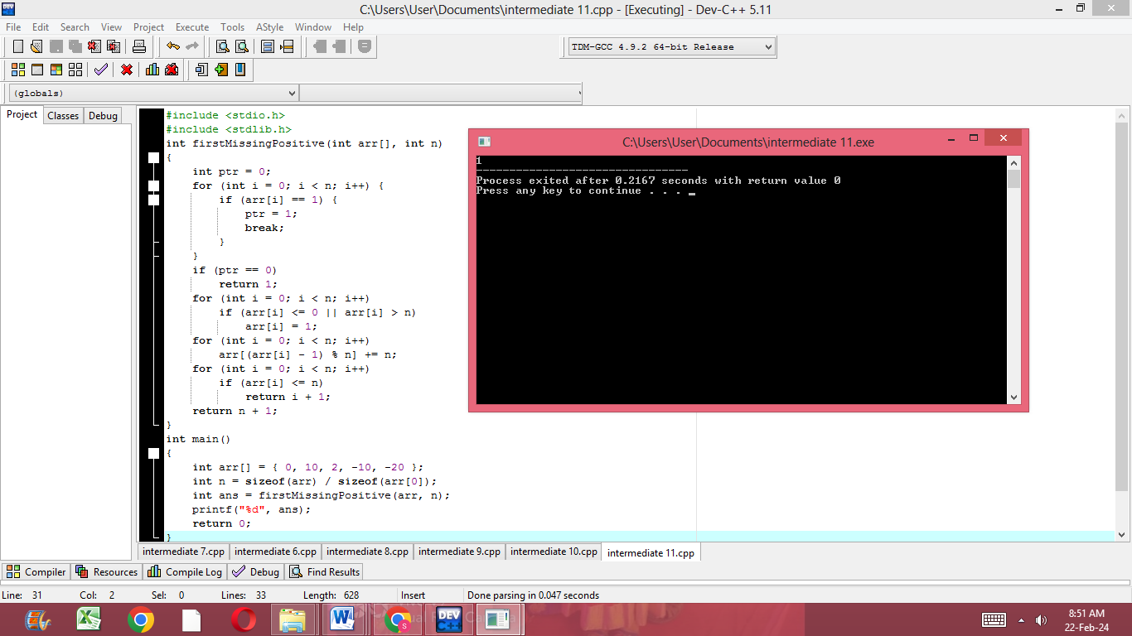

12.Given an array of integers, find the two elements that have the maximum product.

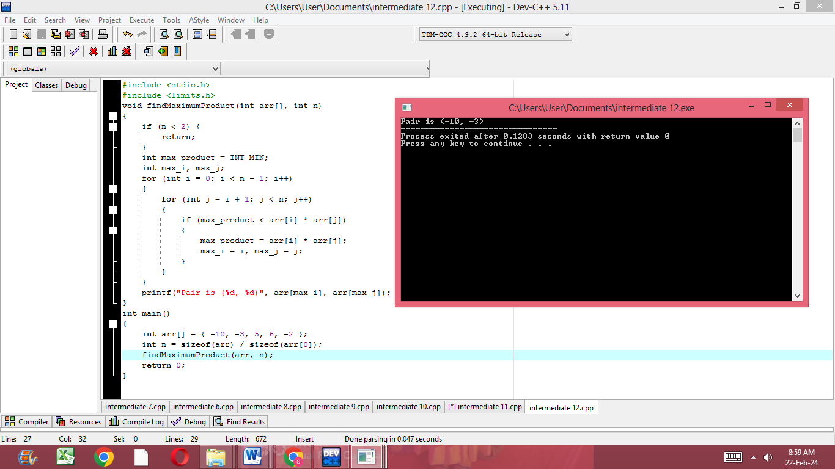

13.Given an array of integers, find the subarray with the maximum product.

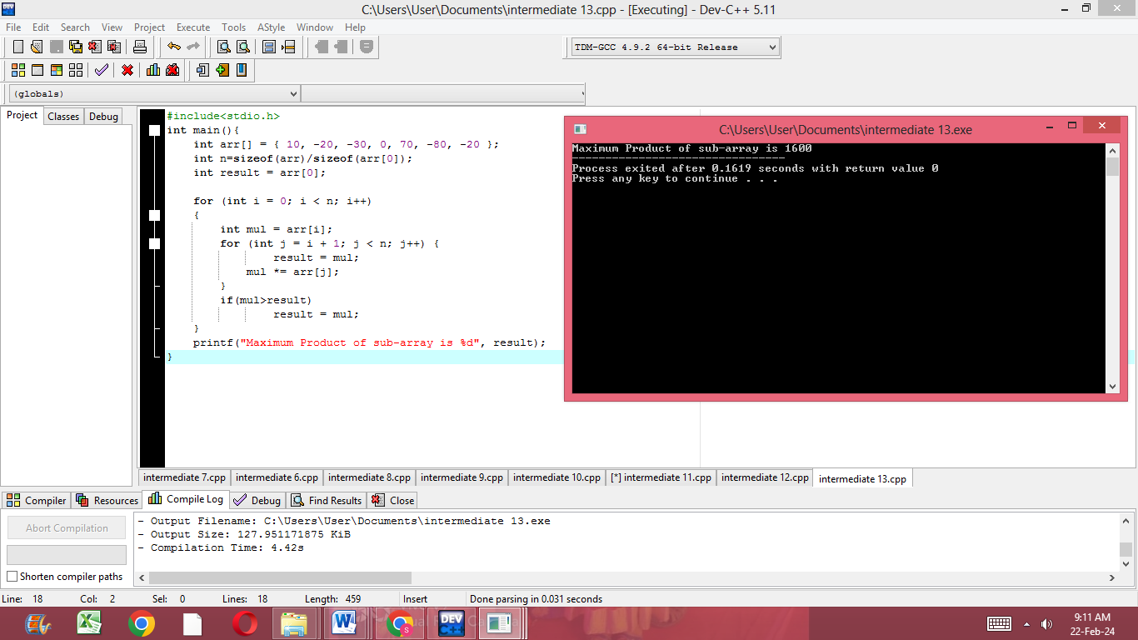

14.Given an array of integers, find the longest subarray with the given sum.

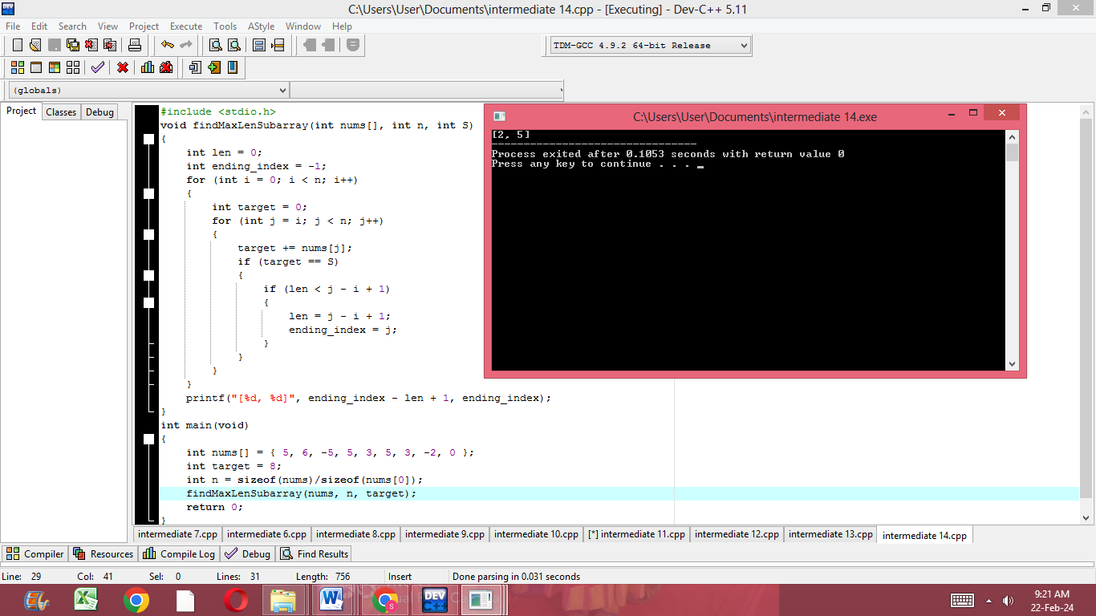

15.Given a matrix (2D array) of integers, find the saddle point(s) (an element that is the minimum in its row and maximum in its column)

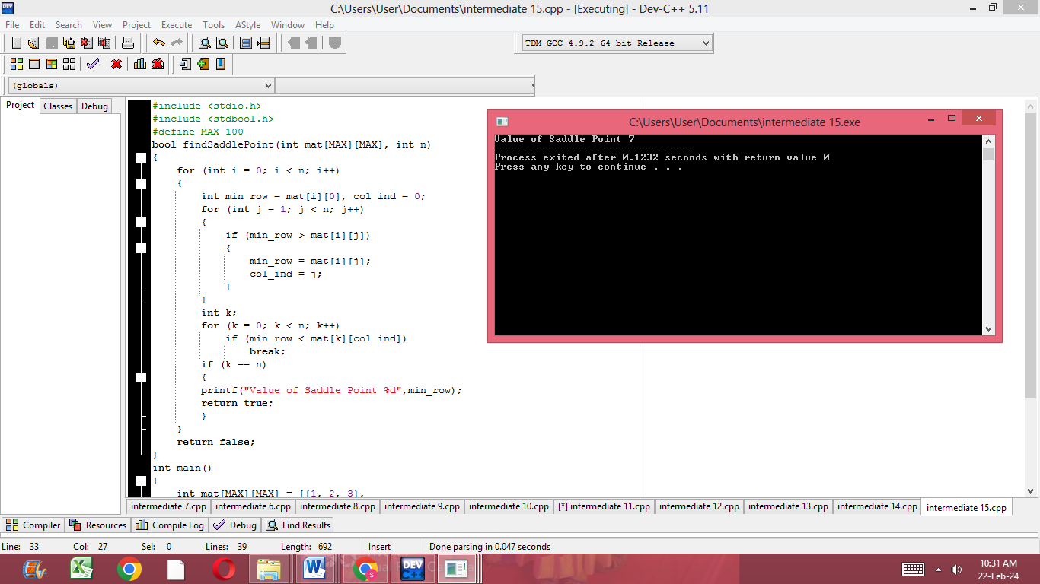

16.Write a program to swap the values of two variables using pointers.

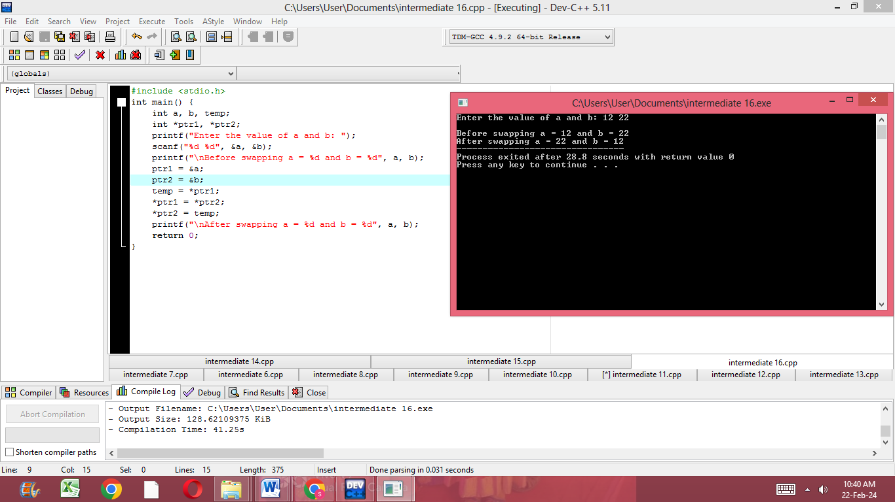

17.Write a program to find the length of a string using pointers.

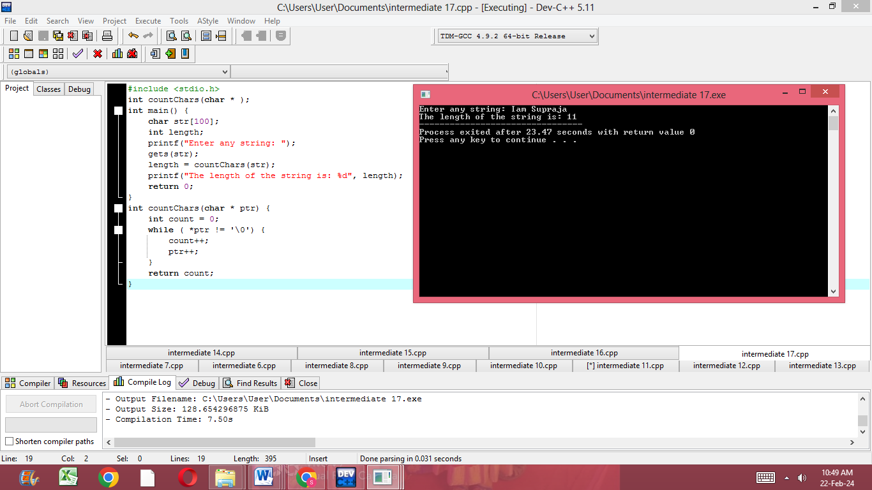

18.Write a program to reverse a string using pointers.

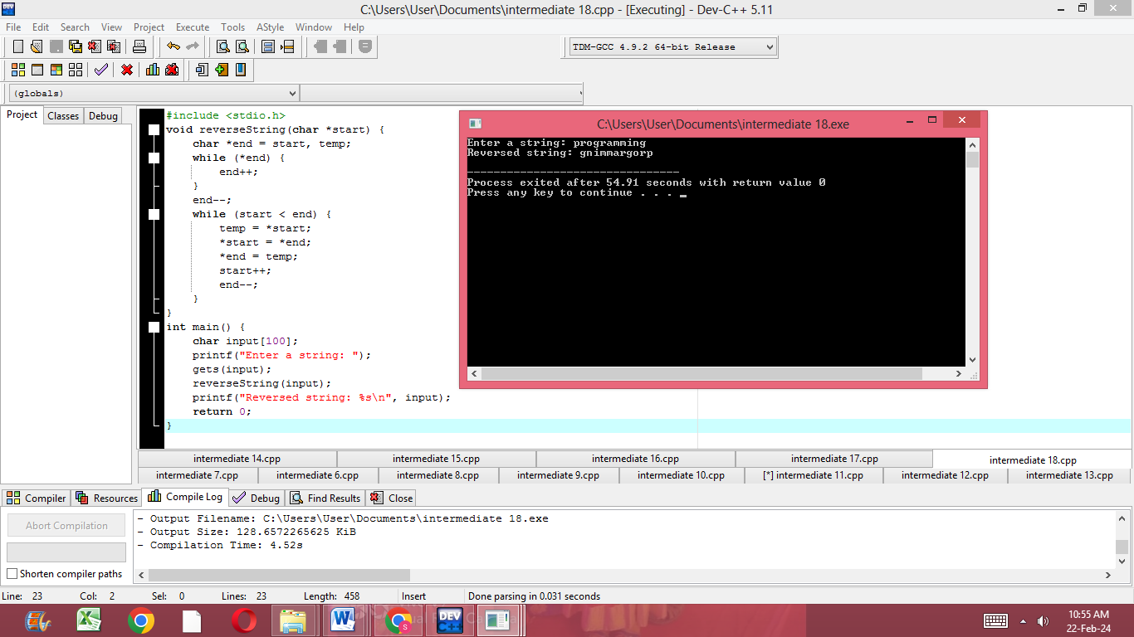

ANALYTICS DAY 2:

Write a C program to find the longest substring without repeating characters in a given string.

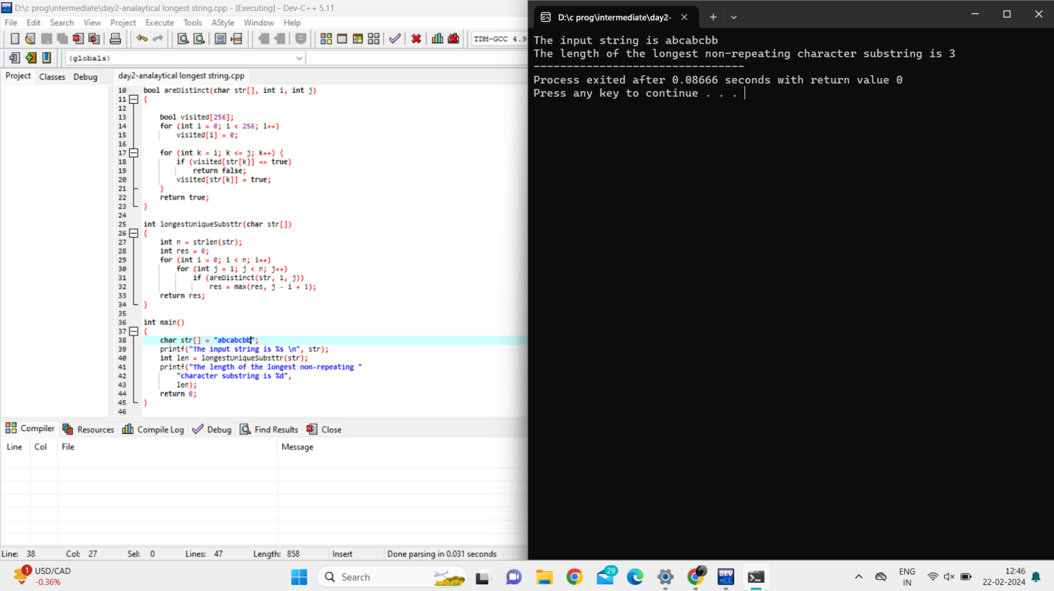

Write a C program to find the maximum product subarray in a given array of integers.

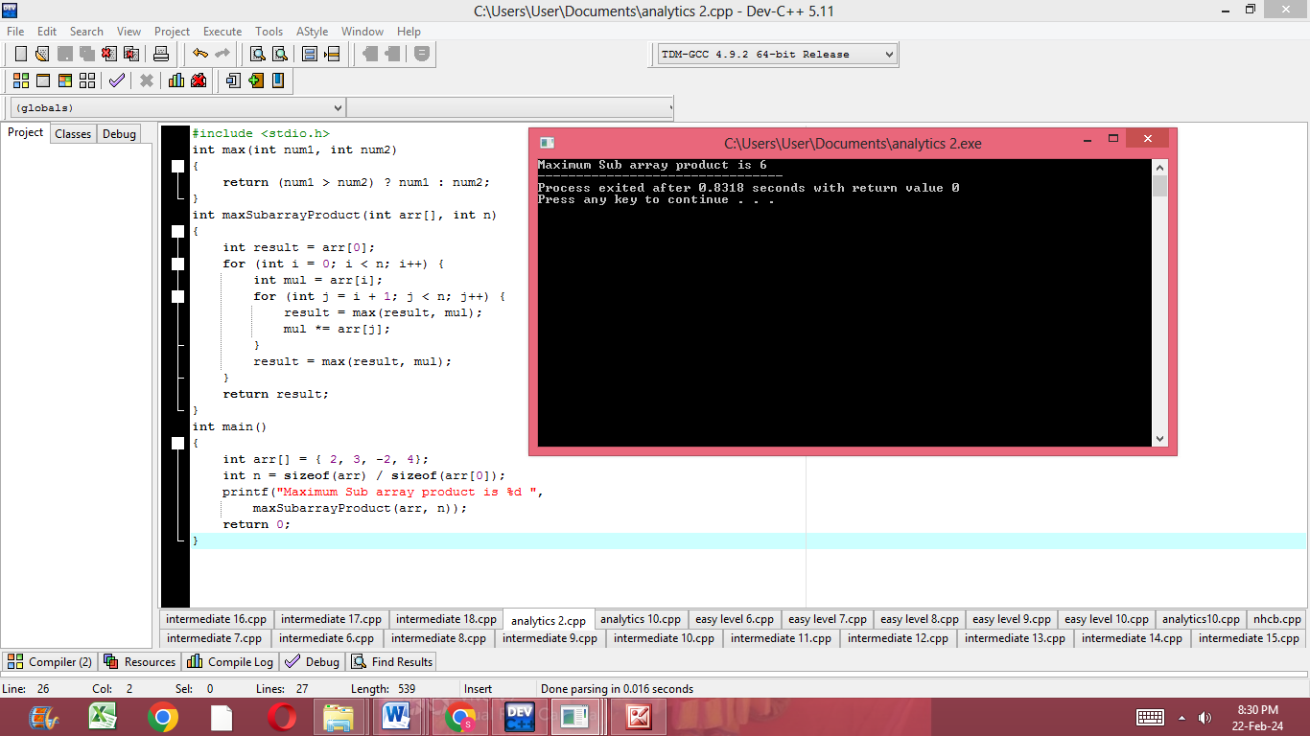

Write a C program to implement a function that rotates a given array of integers to the right by k steps.

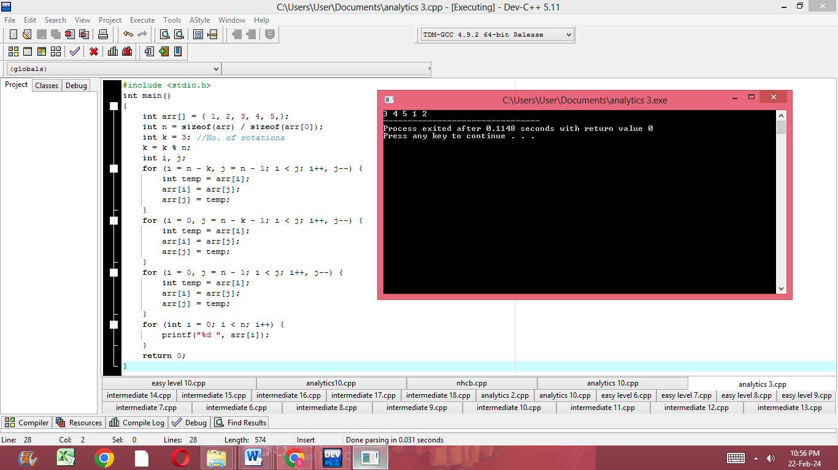

Write a C program to find the longest common prefix string amongst an array of strings.

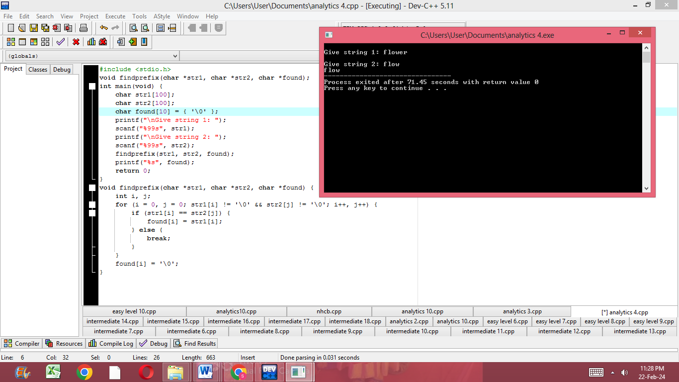

Write a C program to find all distinct combinations of a given length k from a given array of integers without using the same element twice.

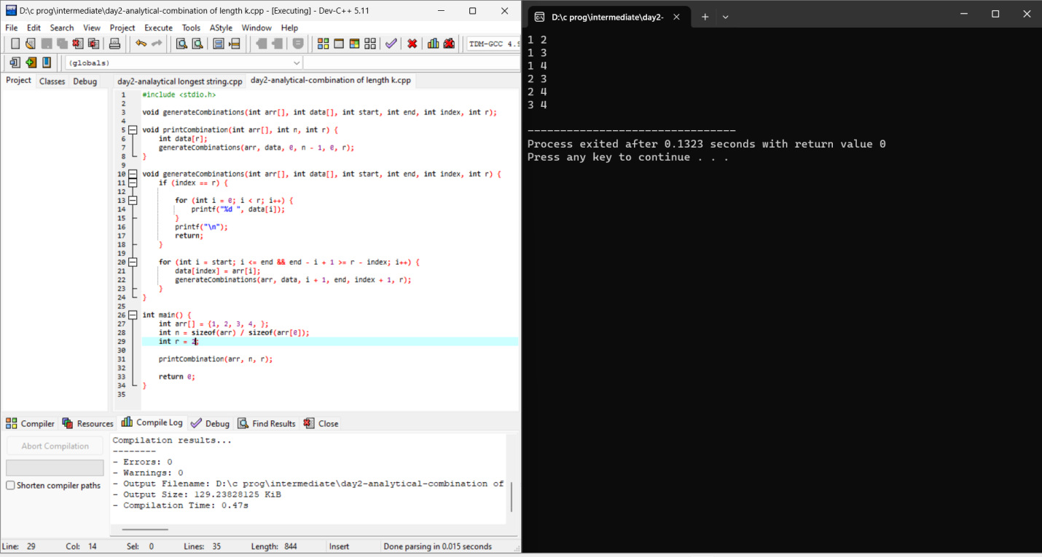

Write a C program to implement a function that removes all duplicates from a sorted array in-place such that each element appears only once and returns the new length.

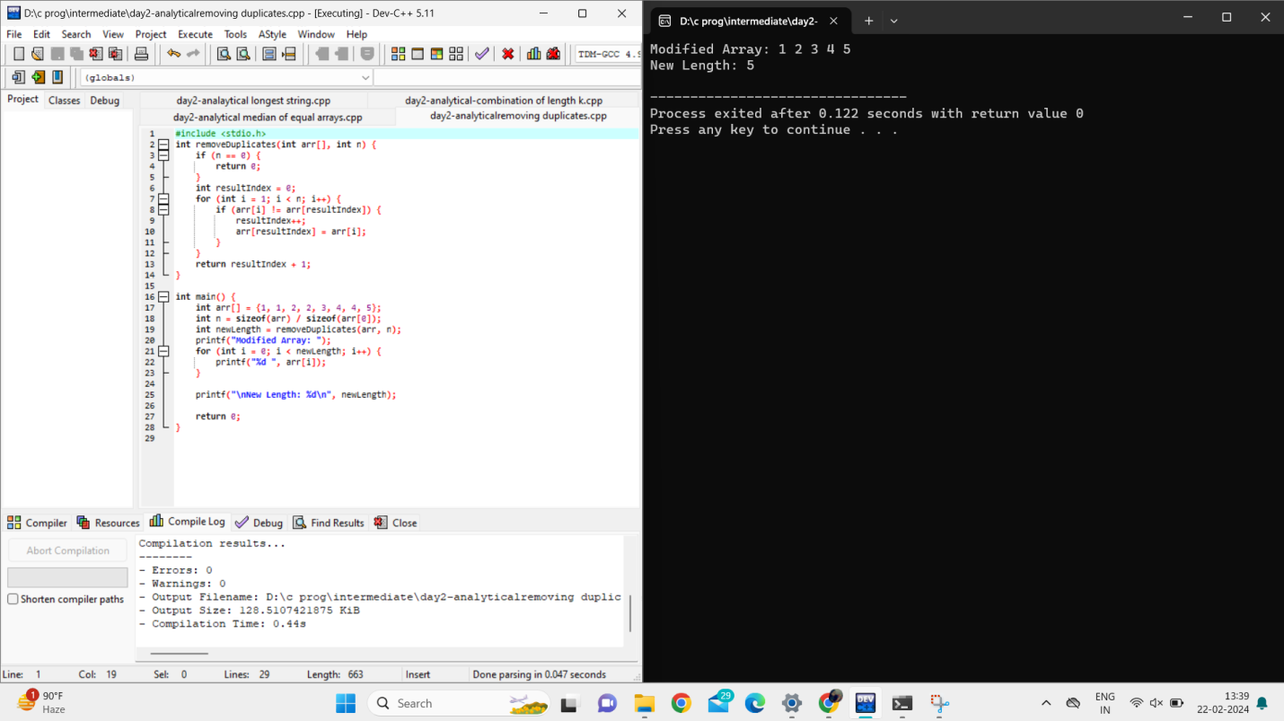

Write a C program to implement a function that determines if a given Sudoku board is valid.

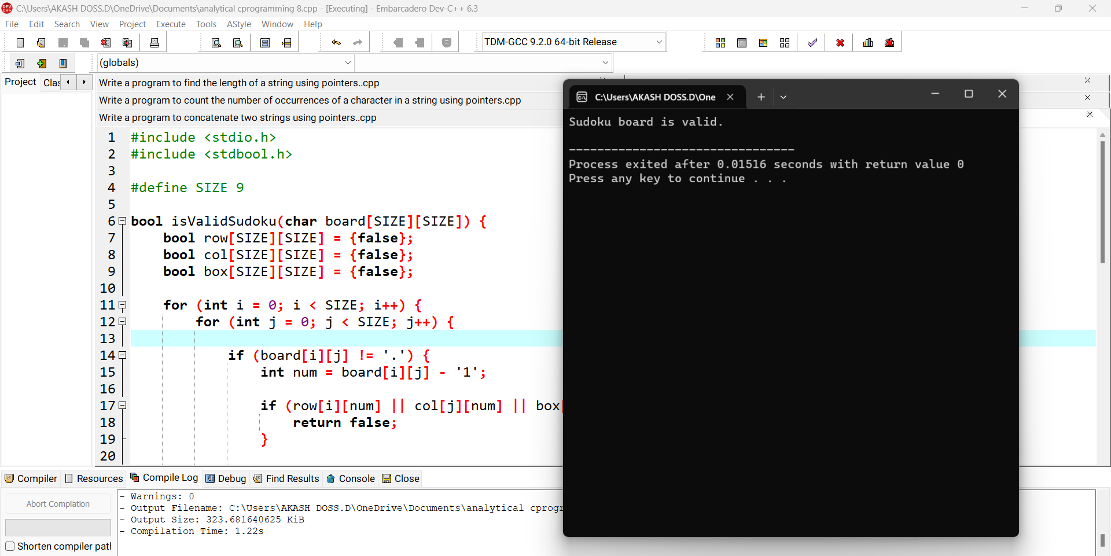

Write a C program to implement a function that returns the index of the first occurrence of a target value in a sorted array.

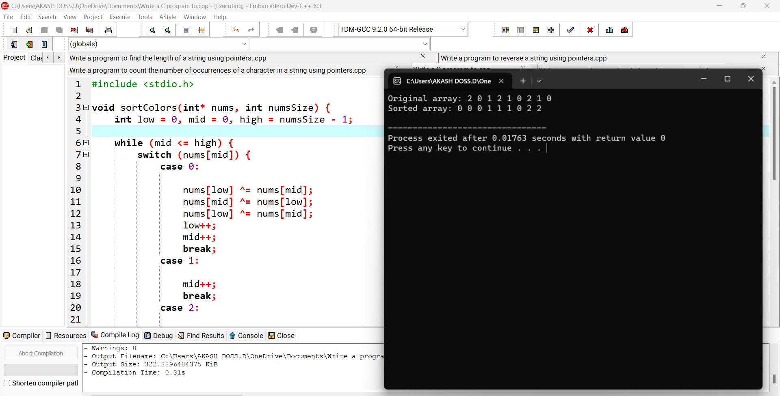

Write a C program to implement a function that returns the median of two sorted arrays of equal size.

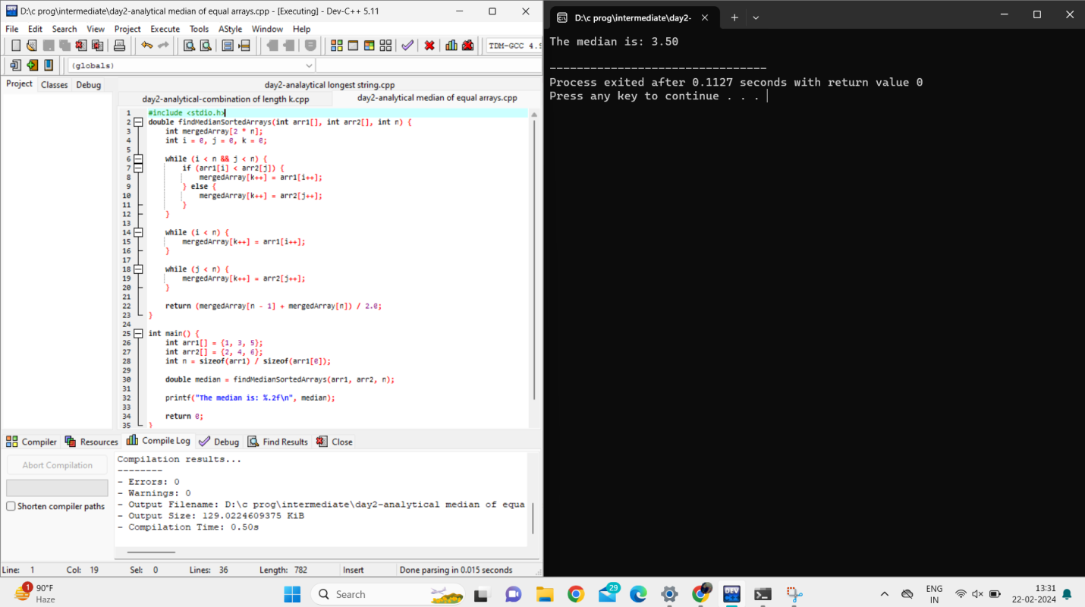

Write a C program to implement a function that sorts an array of 0s, 1s, and 2s .

